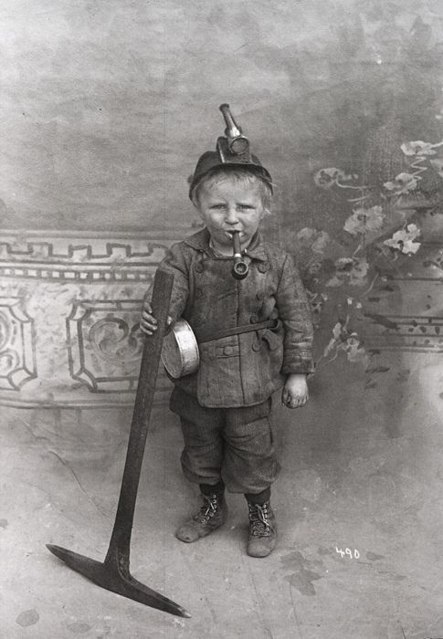**Portrait Photograph 8 Year Old Miner**